20.22: The claimed efficiency of the engine is 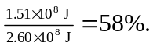 While the most efficient engine that can operate between those temperatures has efficiency 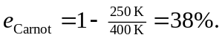
The proposed engine would violate the second law of thermodynamics, and is not likely to find a market among the prudent.

